BUSINESS BLUEPRINT

Document information
Project Name | VinaTech Smart Manufacturing's order status management system
Module | SD – Sales and Distribution
Created by | SangNV , ThanhLT
Version | 1.0
Date | 28/2/2026

Table of Contents

1 OVERVIEW 4
1.1. Glossary 4
1.2. Flowchart shapes usage 5
2 ORGANIZATIONAL STRUCTURE 6
2.1 Sales Organization 6
2.2 Distribution Channel 7
2.3 Division 7
2.4 Sales Office 8
2.5 Plants 8
2.6 Transportation Zone 9
2.7 Shipping Points 10
2.8 Storage Locations 11
3 MASTER DATA 12
3.1 SD-MD-01 Customer Master Data 12
3.1.1 Customer Details 12
3.1.2 Creation/Change/Extension 13
3.1.3 Customer Account Group 14
3.1.4 Account Assignment Group of Customer 14
3.1.5 Regions 15
3.1.6 Sales District 15
3.1.7 Payment Terms 15
3.1.8 Customer Group 16
3.1.9 Price List 17
3.1.10 Shipping Conditions 17
3.1.11 Process Flow 18
3.1.12 Process Description 19
3.2. SD-MD-03 Pricing Master Data 22
3.2.1 List price 22
3.2.2 Pricing Procedures 22
3.2.3 Pricing condition types 22
3.2.4 Process Flow 23
3.2.5 Process Description 24
4 BUSINESS PROCESS 28
4.1 SD-BP-01 Create Sales Order Process 28
4.1.1 Process Flow 29
4.1.2 Process Description 29
4.2 SD-BP-02 Return During Delivery 34
4.2.1 Process Flow 34
4.2.2 Process Description 35
5 REPORTS 38

OVERVIEW

1.1. Glossary
Term | Definition
SD | Sales and Distribution
FI | Finance
FOC | Free of Charge
PO | Purchase Order

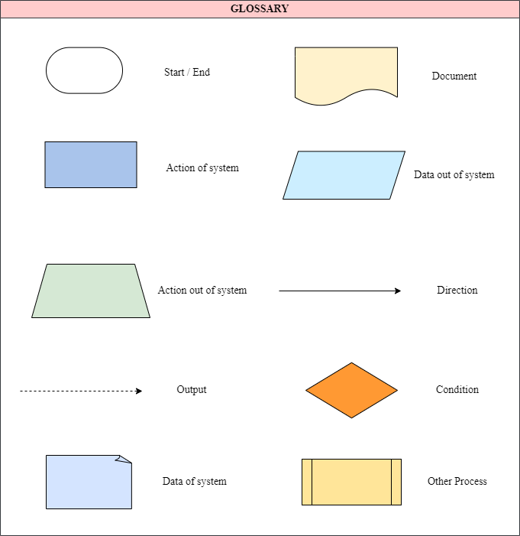
1.2. Flow chart shapes usage

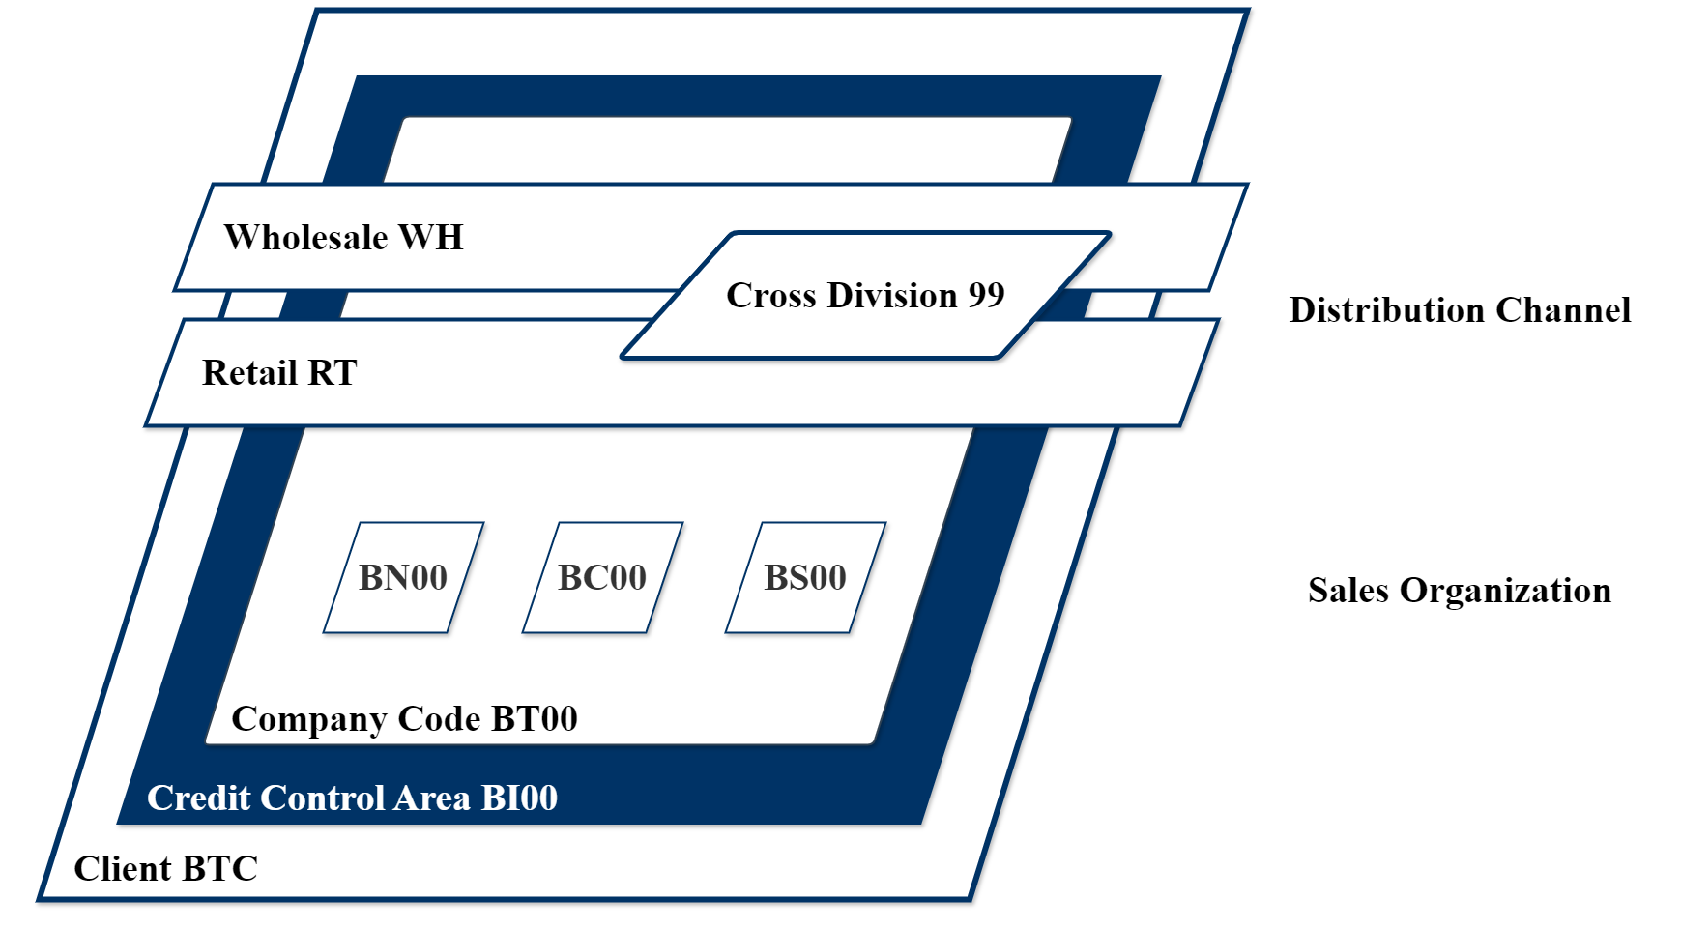
ORGANIZATIONAL STRUCTURE
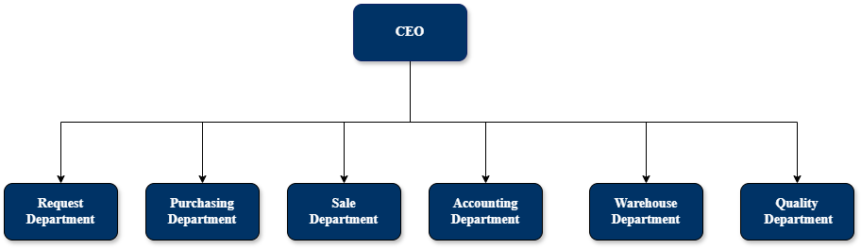
Organization Structure for Company

2.1 Sales Organization
A sales organisation is responsible for all the sales and distribution related activities of all the products offered by Big Trading Company and assigned to one company but a company code can have multiple sales organizations.
The responsibilities of a sales organization are crucial for the efficient management of sales processes, ensuring customer satisfaction, and achieving business objectives.
Configuration Data:
Sales Organization | Description
VT01 | VinaTech Smart Manuf

2.2 Distribution Channel
The medium by which products or services reach the customer is called the distribution channel. Typical examples of distribution channels are wholesale, retail, or direct sales.
Configuration Data:
Distribution Channel | Description
VR | VinaTech Retails
VW | VinaTech Wholesale

2.3 Division
Product groups that can be defined for a wide-ranging spectrum of products form the division. The system uses divisions to determine the sale areas and the business areas for materials, products, or services.
Based on this project, needs to be allowed to occur across multiple divisions or organizational units within the company. Business processes enable a sales organization to manage products or services from divisions other than its own.

Configuration Data:
Division | Description
CB | Circuit Board
E2 | Electronic Component

2.4 Sales Office
The sales office is a physical location where a group works together to perform sales:
Configuration Data:
Sales Offices | Description
VHN1 | VinaTech Hanoi HQ

2.5 Plants
Plants are an organizational unit for dividing an enterprise according to production, procurement, maintenance, and materials planning,... For example, it’s where materials are produced, or goods and services are provided. The plant is an operating area within a company. The plant is assigned to a single company code.
A company code can have several plants. A plant has its material master data.
Configuration Data:

Plants | Description
VTHN | Plant VinaTech Hà Nội
VTHC | Plant VinaTech Hồ Chí Minh
VTBD | Plant VinaTech Bình Dương

F001:The warehouse serves to receive materials, supply manufactured products, store semi-finished/finished goods, and handle shipments.
F002:The warehouse serves to receive materials, supply manufactured products, store semi-finished/finished goods, and handle shipments.
F003:The warehouse serves to receive materials, supply manufactured products, store semi-finished/finished goods, and handle shipments.

2.6 Transportation Zone
Transportation zones are a concept used to group locations. Those groups are then considered as a collective. This endpoint provides methods to create, update, retrieve, and delete transportation zones.
Country | Transportation Zone | Description
VN | 0000000001 | Region North
VN | 0000000002 | Region South
VN | 0000000003 | Region Central

2.7 Shipping Points
The physical location (a warehouse or collection of loading ramps) from which materials are shipped
You can predefine shipping/ receiving points in the system, based on different combinations of:
- Plants
- Shipping conditions
During delivery processing, the shipping/receiving points is the most important criterion that you can use to select deliveries.
A delivery can be shipped from one shipping point only or received at one receiving point only.
Shipping Points | Description
SP01 | In-house Transportation
SP02 | Express / Outsourced Delivery

2.8 Storage Locations
The storage location is an organization unit that differentiates material stocks within a plant. Inventory Management on a quantity basis is carried out at the storage location level in the plant.
Within a plant, one or more storage locations can be set up. The management of the stocks can be handled on storage location level. A storage location must be created for individual plants if the execution of material stocks is to happen in the ERP system.
Configuration Data:
Storage Locations | Description
FG01 | Finished Goods

MASTER DATA

3.1 SD-MD-01 Customer Master Data

3.1.1 Customer Details
General Data:
Business Partner Number: Unique identifier for the customer.
BP Category : Organization / Person.
BP Grouping : Account Group.
Name: Customer's name.
Search Term : Used to quickly search customers in BP.
Address:
- Street
- City
- Postal Code
- Country
- Region
Communication:
- Telephone Number
- Email Address
- Website
Control Data:
- Industry
- Tax Number
- VAT Registration Number
Contact Persons:
- Name
- Department
- Function
- Telephone Number
- Email Address

3.1.2 Creation/Change/Extension
In SAP Sales and Distribution (SD), creating, changing, and extending customer master data involves using specific transactions to manage customer information.
Purpose of creating customer master data: Create customer master data including general, company code, and sales area data.
Create customer master data:
- Enter the customer number
- Fill in the general data such as name, address, communication, and bank details.
- Enter the company code data like reconciliation account and payment terms.
- Enter the account group
- Enter the sales area data including sales organization, distribution channel, division, and relevant sales, shipping, billing, and partner functions information.
Purpose of Changing Customer Master Data: Change existing customer master data including general, company code, and sales area data.
- Enter the customer number.
- Navigate to the section (general data, company code data, or sales area data) that needs to be updated.
- Make the necessary changes and save.

3.1.3 Customer Account Group
Account Group | SAP Description
ZVT1 | VTC Corporate Customers
ZVT2 | VTC Agents/Dealers
ZVT3 | VTC One-time Customers

3.1.4 Account Assignment Group of Customer

Account Assignment Groups are important for determining G/L accounts during sales posting. Need information if more account assignment groups are required.
Account Assignment Group of Customer | Description
01 | Domestic Revenues

3.1.5 Regions
Regions | Description
HN | Hà Nội
BD | Bình Dương
SG | Hồ Chí Minh

3.1.6 Sales District
Assign customers to a geographical sales district and use the sales district to generate sales statistics.
Sales District | Description
VN0001 | Northside Vietnam

3.1.7 Payment Terms
Payment Term defines the conditions that a customer or supplier must follow to make a payment. It includes payment time, due date, early payment discount, and other conditions related to payment. In this case, we require the customer to pay in full and at once.
Role of Payment Term in Business Process:
- Cash flow management: Payment Term helps businesses manage cash flow effectively by clearly defining payment terms and early payment discounts.
- Optimize profits: Early payment discounts encourage customers to pay early, helping businesses have faster cash flow and reducing bad debt risks.
- Risk management: Clearly defining payment terms helps minimize the risk of disputes and ensures that financial conditions are adhered to.
- Improve customer and supplier relationships: Clear and reasonable payment terms help build better relationships with customers and suppliers, promoting trust and long-term cooperation.
Payment Terms | Description
ZVT1 | Payable immediately Due net

3.1.8 Customer Group
Assign a customer group to an individual customer in either the customer master record of the sold-to party or in the sales document. Creating condition types are pricing records for customer groups, and generating sales statistics.
Customer Group | Description
02 | Retail
08 | Wholesale

3.1.9 Price List
Price group (customer): A grouping of customers who share the same pricing requirements.
Price list type: Identifies a price list or other condition type (for example, a surcharge or discount).
Price Group | Description
01 | Bulk buyer
02 | Occasional buyer

3.1.10 Shipping Conditions
Shipping conditions are used to define a specific handle of the goods or even to determine a route. Since Shipping Conditions are a must have for Routing they are important for the Shipping Department.

Shipping Condition | Description
01 | Standard
RE | Returns

3.1.11 Process Flow
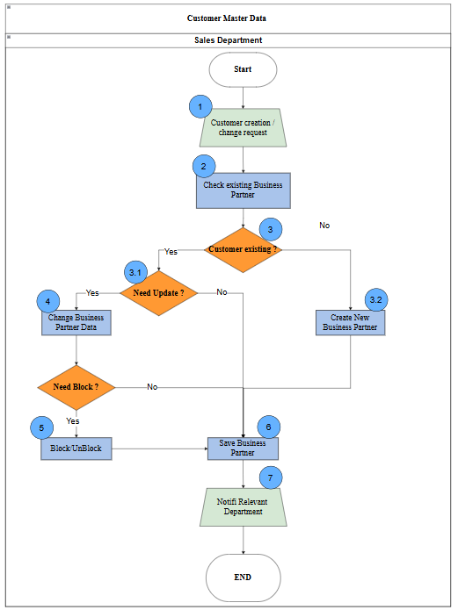

3.1.12 Process Description
Step | Step Name | Detailed Description | Role
1 | Customer creation / change request | Input: Request to create or update customer data.  Explain: Sales sends a request for customer master maintenance.  Output: Request is submitted. | Sales Department
2 | Check existing Business Partner | Input: Customer request information.  Explain: Finance / Master Data Team checks whether the Business Partner already exists in the system.  Output: Existing status confirmed. | Sales Department
3 | Customer exists? | Input: Search result in system. Explain: Decide whether the customer already exists. If no, create a new BP. If yes, continue checking update need.  Output: Decision made. | Sales Department
3.1 | Need Update? | Input: Existing customer data and request details.  Explain: Check whether the current BP data needs to be updated.  Output: Update requirement confirmed. | Sales Department
3.2 | Create New Business Partner | Input: Existing customer data and change request.  Explain: Check whether customer master data needs to be updated.  Output: Update need confirmed. | Sales Department
4 | Change Business Partner Data | Input: Existing BP data and revised customer information. Explain: Update Business Partner data in the system.  Output: BP data changed. | Sales Department
4.1 | Need Block? | Input: Customer status / business requirement.  Explain: Check whether the customer should be blocked or unblocked.  Output: Block decision confirmed. | Sales Department
5 | Block / Unblock | Input: Block decision.  Explain: Execute block or unblock for the Business Partner.  Output: BP status updated. | Sales Department
6 | Save Business Partner | Input: New or updated BP data. Explain: Save the final Business Partner record in the system. Output: BP saved successfully. | Sales Department
7 | Notify relevant departments | Input: Saved BP record.  Explain: Inform related departments that customer master data has been created or updated.  Output: Departments notified. | Sales Department

3.2. SD-MD-02 Pricing Master Data

3.2.1 List price
For Domestic Sales, VinaTech has a list of prices, which are: Goods List Price
This is used to determine the selling price during the sales order process.

3.2.2 Pricing Procedures
Pricing Procedure | Description
VTC001 | VTC Price

3.2.3 Pricing condition types
Condition type | Copy from Condition type | Description | Pricing Procedure
 |  |  | VTC001
PRVT | PR00 | Base Price | x
ZDIS |  | VinaTech Discount | x
MWST | MWST | Output Tax | x

3.2.4 Process Flow
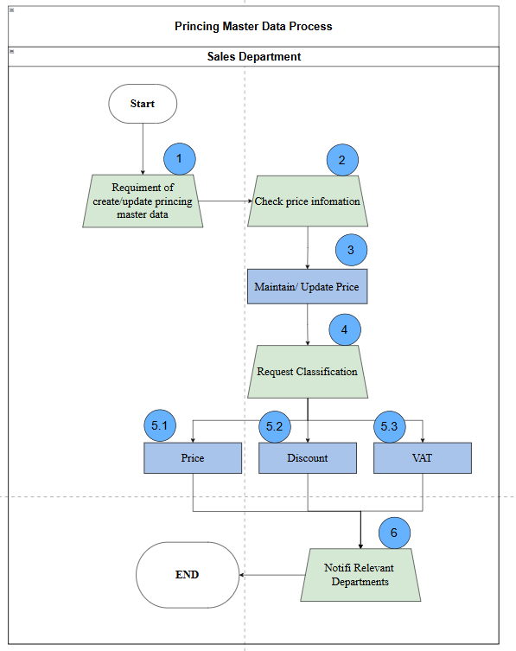

3.2.5 Process Description
Step | Step Name | Detailed Description | Role
1 | Requirement of pricing master data | Input: Request to create or update pricing information.  Explain: Sales Department submits a request to maintain pricing conditions (base price, discount, VAT, freight) according to corporate or market policies.  Output: Pricing request is reviewed and approved. | Sales Department
2 | Check price information | Input: Approved pricing request.  Explain: Sales Staff checks existing condition records in the system (VK13). If pricing data exists and requires changes, proceed to Step 3. If not, create new condition records.  Output: Confirmation of pricing status. | Sales Department
3 | Maintain/ Update price | Input: Price Information from outside system.  Explain: Sales Staff creates or updates pricing conditions using VK11 or VK12 for:  PR00 – Base Price  K007 – Discount  MWST – VAT  KF00 – Freight  If pricing conditions need classification, proceed to Step 4.  Output: Updated pricing master data. | Sales Department
4 | Request Classification | Classify conditions about pricing information:  Input: Information Data from outside system.  Explain:  If base price changes due to corporate policy, proceed to Step 5.1.  If the discount changes, proceed to Step 5.2.  If VAT changes due to government regulation, proceed to Step 5.3.  Output: Pricing change classified by condition type. | Sales Department
5.1 | Base price | Input: Condition Type, Sales Organization, Distribution Channel, Division.  Explain: Sales Department maintains or updates the base price condition record to reflect the new selling price.  Output: Base price condition is updated. | Sales Department
5.2 | Discount | Input: Condition Type, Sales Organization, Distribution Channel, Division.  Explain: Sales Department maintains or updates the discount condition according to customer policy or corporate pricing policy.  Output: Discount condition is updated. | Sales Department
5.3 | VAT (Value Added Tax) | Input: Condition Type , Country, Sales Organization, Distribution Channel, Division,.  Explain: Sales Department updates the VAT condition according to current tax regulations to ensure correct tax calculation during sales and billing.  Output: VAT condition is updated. | Sales Department
6 | Notify relevant departments | Explain: Sales Department notifies relevant departments so that the updated pricing conditions can be applied in sales processing and billing.  Output: Relevant departments are notified of the updated pricing master data. | Sales Department

BUSINESS PROCESS

4.1 SD-BP-01 Create Sales Order Process

4.1.1 Process Flow
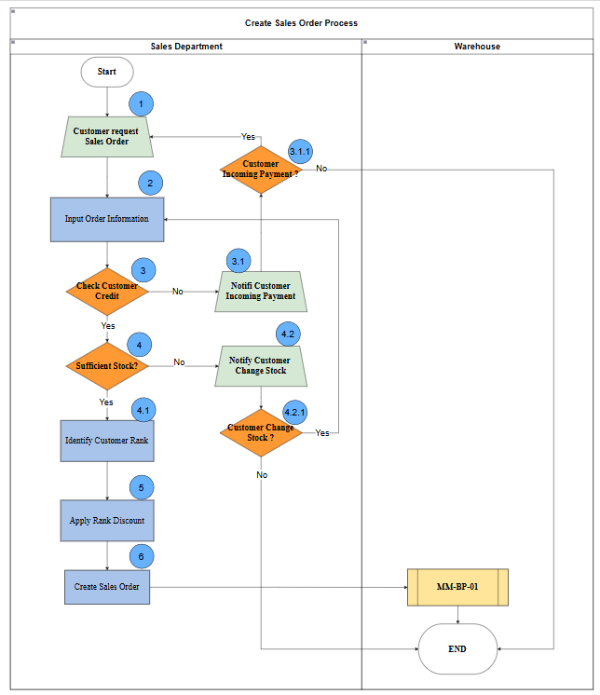

4.1.2 Process Description

Step | Step Name | Detailed Description | Role
1 | Customer request Sales Order | Input: Customer inquiry  Explain: The Sales Department receives the sales order request from the customer .  Output: Customer sales order request is received and recorded. | Sales Department
2 | Input Order Information | Input: Business Partner, Payment Terms  Explain: The Sales Department enters all required sales order data into SAP based on the customer request and business conditions.  Output: Sales order data is created and saved in the system. | Sales Department
3 | Check Customer Credit | Input: Material Item, Order Quantity, Sales Unit  Explain: The Sales Department checks the customer’s credit status in SAP to ensure the order does not exceed the allowed credit limit and that overdue receivables are controlled.  Output: Credit status is determined | Sales Department
3.1 | Notify Customer Incoming Payment | Explain: If the customer has overdue payment or insufficient credit, the Sales Department informs the customer to make payment before continuing the process.  Output: Payment notification is sent to the customer. | Sales Department
3.1.1 | Customer Incoming Payment ? | Input:Customer open items.  Explain: The Sales Department checks in SAP whether the customer payment has been received and posted successfully.  Output: Payment status is confirmed | Sales Department
4 | Sufficient Stock? | Input: Material Code, Plant, Storage Location;  Explain:The Sales Department checks product availability in SAP to determine whether enough stock exists to fulfill the sales order.  Output: Stock availability is confirmed | Sales Department
4.1 | Identify Customer Rank | Explain:The Sales Department identifies the customer rank based on master data .  Output: Customer rank is identified. | Sales Department
4.2 | Notify Customer Change Stock | Explain:If stock is insufficient, the Sales Department informs the customer about the shortage and proposes quantity changes, delivery rescheduling, or substitute products.  Output: Customer is informed about stock changes. | Sales Department
4.2.1 | Customer Change Stock? | Input:Material Code, Plant, Storage Location;  Explain:The Sales Department checks whether the customer accepts the revised stock arrangement.  Output: Customer confirmation is received | Sales Department
5 | Apply Rank Discount | Explain: The Sales Department applies the relevant discount condition in SAP according to the customer rank .  Output: Discount is applied to the sales order. | Sales Department
6 | Create Sales Order | Input:Business Partner, Sales Area, Company Code, Material , Order Quantity, Plant, Delivery Date, Payment Terms, Incoterms.  Explain:The Sales Department creates the official sales order in SAP after all validations are completed.  Output: Sales Order document is created successfully. | Sales Department

4.2 SD-BP-02 Customer Return Delivery

4.2.1 Process Flow

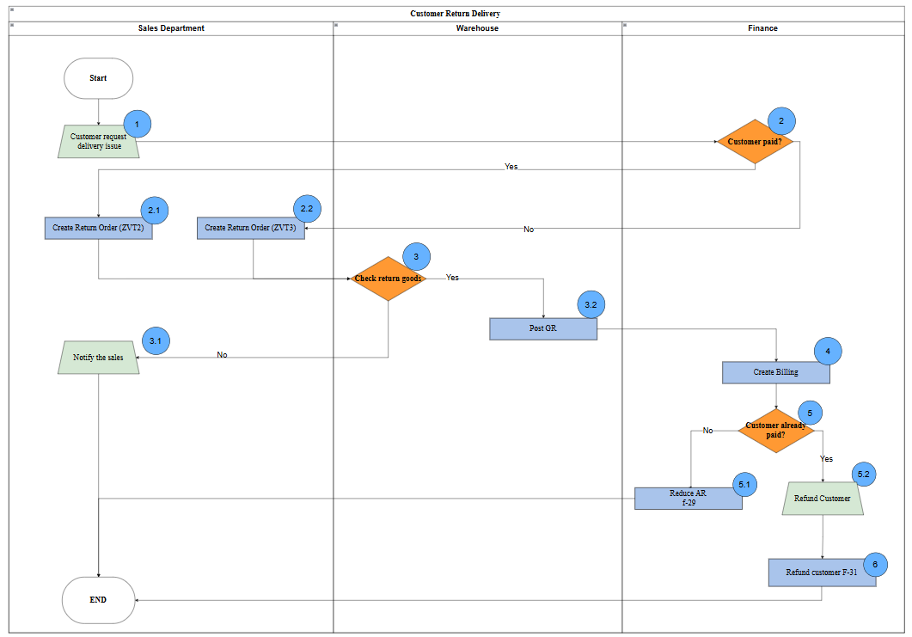

4.2.2 Process Description

Step | Step Name | Detailed Description | Role
1 | Customer request delivery issue | Input: Original Delivery/Invoice.  Explain: Customer reports a delivery issue to the Sales Department.  Output: Request is recorded. | Sales Department
2 | Customer paid? | Explain: Finance verifies if the payment for the original invoice has been completed to determine the return document type.  Output: Branching to ZVT2 or ZVT3. | Finance
2.1 | Create Return Order (ZVT2) | Explain: If the customer has already paid, Sales creates a Return Order type ZVT2.  Output: ZVT2 Order created. | Sales Department
2.2 | Create Return Order (ZVT3) | Explain: If the customer has not paid, Sales creates a Return Order type ZVT3.  Output: ZVT3 Order created. | Sales Department
3 | Check return goods? | Explain: Warehouse inspects the physical items to ensure they match the return request and quality standards.  Output: Accept (Yes) or Reject (No). | Warehouse
3.1 | Notify the sales | Explain: (No branch of Step 3) Warehouse rejects the items and notifies Sales of the discrepancy.  Output: Process ends. | Sales Department
3.2 | Post GR | Explain: (Yes branch of Step 3) Warehouse accepts the goods and posts a Goods Receipt to increase inventory.  Output: Inventory updated in system. | Warehouse
4 | Create Billing | Input: Post GR document.  Explain: Finance creates a Credit Memo/Billing document based on the received goods.  Output: Billing document created. | Finance
5 | Customer already paid? | Explain: Final check to decide between account clearing or actual cash refund.  Output: Branching to AR reduction or Refund. | Finance
5.1 | Reduce AR (f-29) | Explain: Finance performs a clearing entry using transaction F-29 to reduce the customer's outstanding balance.  Output: AR reduced. | Finance
5.2 | Refund Customer | Explain: Sales/Finance initiates the formal refund request for the paid amount.  Output: Refund request approved. | Finance
6 | Refund customer (F-31) | Explain: Finance executes the actual payment back to the customer using transaction F-31.  Output: Payment completed; Process ends. | Finance

REPORTS

No. | Description | T-Code
1 | Sales Order | VA01
2 | Order Delivery | VL01N
3 | Good Issue Note + Delivery Receipt | VL02N
4 | VAT Invoice | VF01
5 | Return Order | VA01
6 | Returns Delivery | VL01N

